Quick Start Guide

# Setup Firebase Account

Firebase is a web service that is used to store participant responses. Accounts are free and free if the amount of data and bandwidth used falls under certain limits. Please see the firebase [website](https://firebase.google.com/pricing/) for more details. The free plan is usually sufficient for most small to medium research projects.

1. Visit the firebase website: https://firebase.google.com/
2. Click “Sign In”. Sign in using an existing google account.
3. Click “Go to Console”
4. Create a new “Project”. Select the project.
5. Click “Add Firebase to your web app”

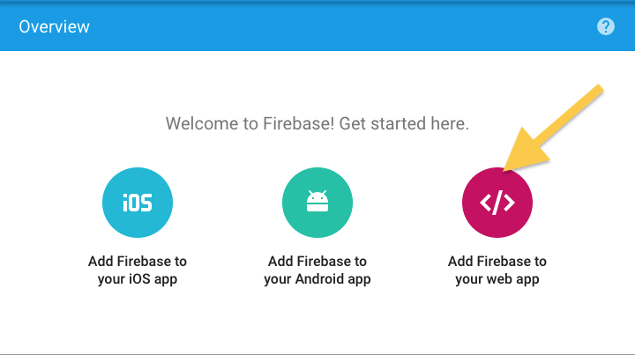

1. Make a note of the **API key** and the **databaseURL**
2. Select the “Database” tab from the left menu.

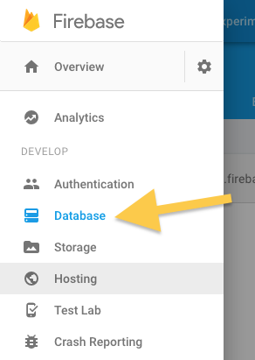

1. Select the “Rules” tab and replace the firebase rules here with the text in the included file “security\_rules.json”.
2. Click “Publish” to save your changes.

# Download and Install XAMPP

1. Visit the XAMPP website: <https://www.apachefriends.org/index.html>
2. Download the version of XAMPP that matches your operating system (Windows, Mac and Linux are supported)
3. Follow XAMPP on-screen install instructions
   1. On Windows, XAMPP installs in C:\XAMPP\
   2. On Macs, XAMPP installs in /Applications/XAMPP
   3. This is known as the XAMPP root folder **[XAMPP\_ROOT\_FOLDER]**
4. Start up the XAMPP server using the XAMPP control panel which is located:
   1. Windows [XAMPP\_ROOT\_FOLDER]\xampp-control.exe
   2. Mac [XAMPP\_ROOT\_FOLDER]\manager-osx
5. Select "Manage Servers". Click on the "Apache Web Server" list item. Click "Start".

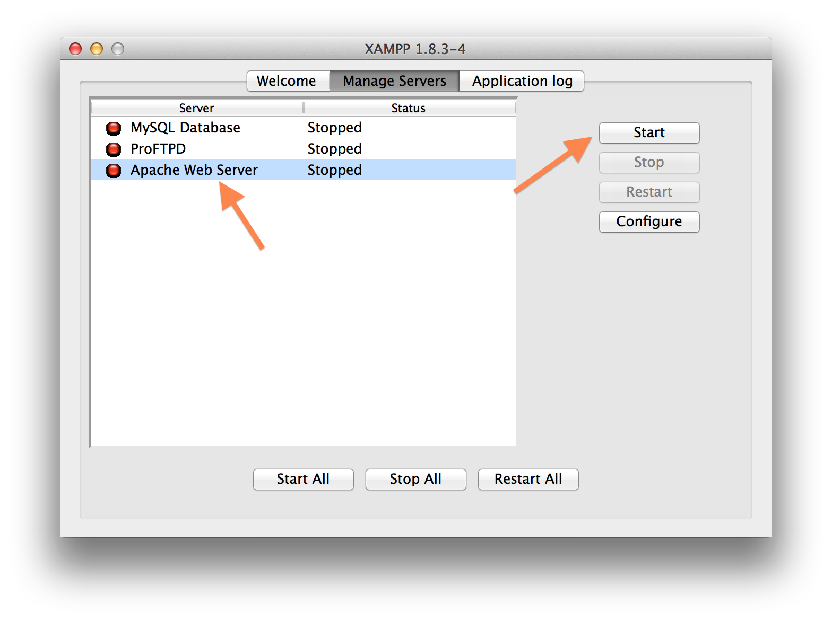

# Configure Web Files

1. Unzip the attached zip file. This should create a folder called "roofRunner", “bridgeGame”, “teleporters” or “esp” depending on which game you are working with.
2. Move the folder to [XAMPP\_ROOT\_FOLDER]/htdocs/
3. Open [XAMPP\_ROOT\_FOLDER]/htdocs/roofRunner/js/firebaseConfig.json in a plain text editor.
4. Edit lines 2 and 3. Replace “YOUR\_API\_KEY\_HERE” and “YOUR\_DATABASE\_URL\_HERE” with the api key and d “atabase URL obtained from the Firebase as described in the “Setup Firebase Account” section of this document.

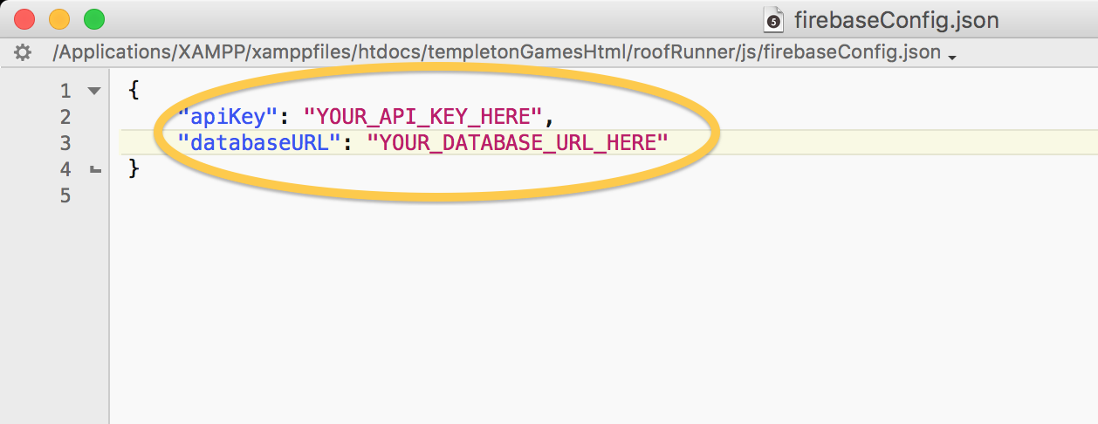

# Test the Web App

1. Launch a web browser.
2. Enter the following URL into your browser
   1. Roof runner game:

http://localhost/roofRunner/#/?expId=simpleExp

* 1. Teleporters game

http://localhost/teleporters/#/?expId=simpleExp

* 1. Bridge game

http://localhost/bridgeGame/#/?expId=simpleExp

* 1. ESP game

http://localhost/esp/#/?expId=simpleExp

1. You should see the instructions for the game, followed by a consent form, background questionnaire, detailed instructions and finally the game itself. At the end of the game, you should be presented with a set of post-game questions.

# Download Results

1. At the end of the game, you will see this screen: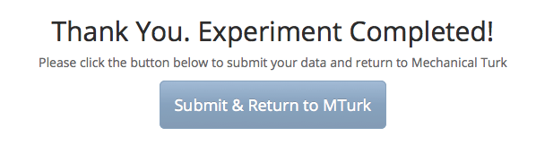
2. Log into your firebase account
3. Select the “Database” menu item from the left menu. Then select the “Data” tab.
4. Data is stored as [JSON](http://www.json.org/) objects that can be previewed in the browser. The critical data is stored in the “data” object. When testing the game, all of your data will be stored under a worker ID called “debug”.
5. Select your project then click on the “Database” tab.

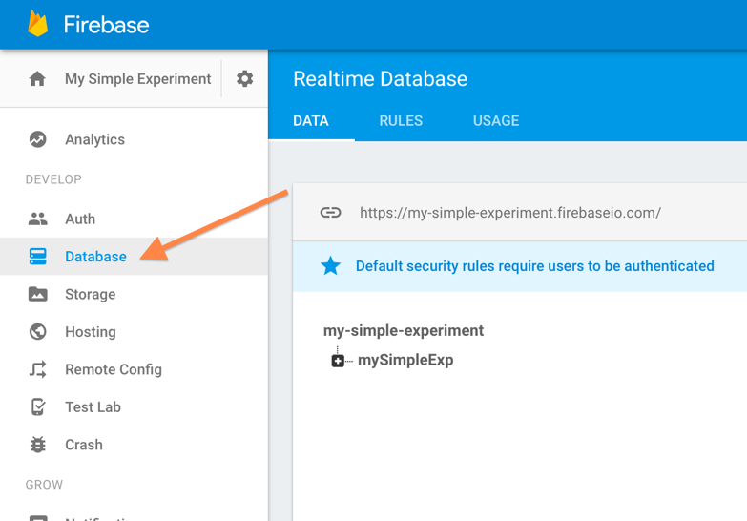

1. **Do not download the data at the root level.** Instead, click on your experiment in the tree view to select it.

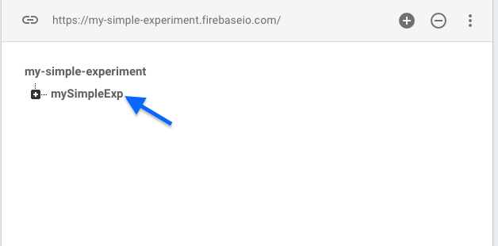

Select the more options buttonimages/more_options_button.png. Then click “Export JSON”.

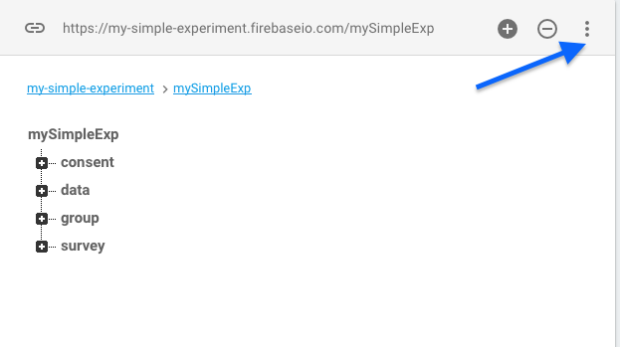

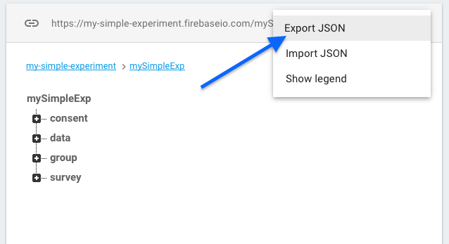

1. Download your data using the “Export Data” button.
2. If the data you have collected is greater than 1MB, you may see this message:

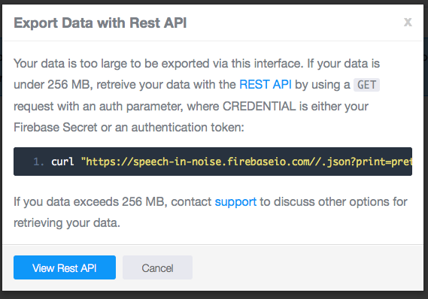

* Copy the “curl https://…” line to your clipboard.
* Close the “Export Data with REST API” window.
* Click on the gear icon near the top left of the firebase console page. Then select “project settings”

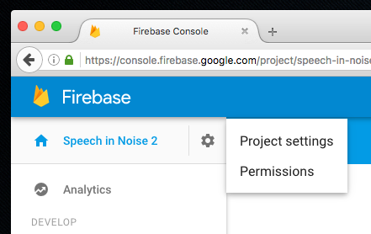

* Select the “Database” tab, hover over the password field and click “show”. Copy this credential key.

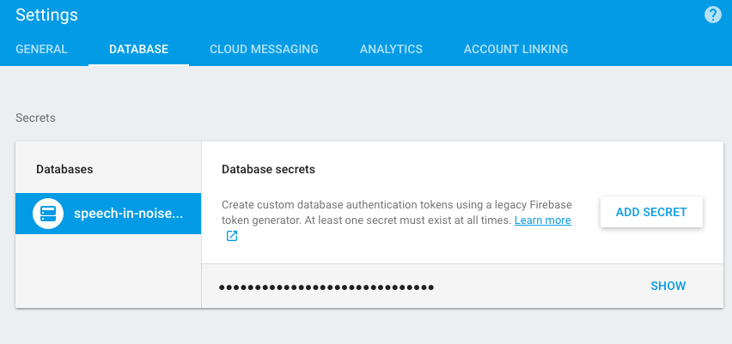

* Launch a terminal (OSX) or PowerShell (Windows).
* Paste the “curl https://…” into the terminal or Powershell window.
* Replace “CREDENTIAL” with your credential key that you obtained from the Database Secrets section.
* Append “-o “ followed by the path of the file where you want the data saved to. For example:

curl “https://my-simple-exp.firebaseio.com//.json?print=pretty&auth=ABC1234” -o /Users/john/Desktop/myData.json